COMPANY NAME AND LOGO

Customer Details
Full Name: ABDULAI ABDUL-KARIM
Phone: 0593790996
Ghana Card Number: GHA-726785825-2

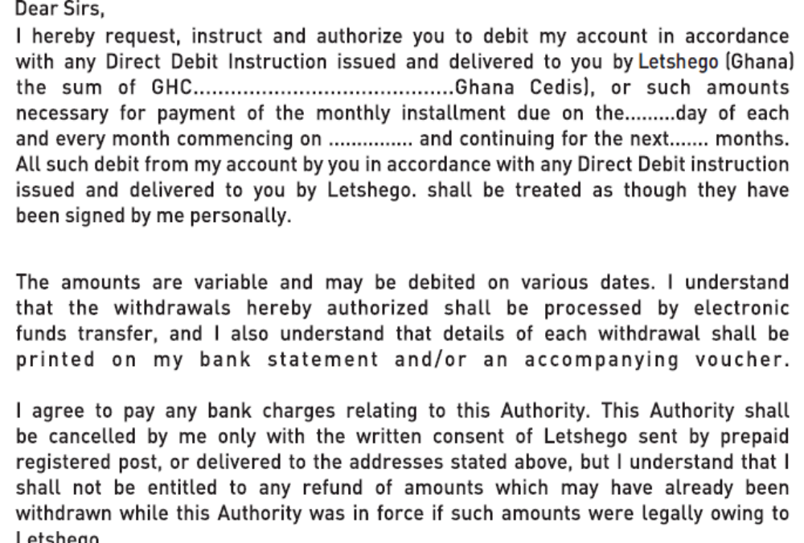

BANK DETAILS

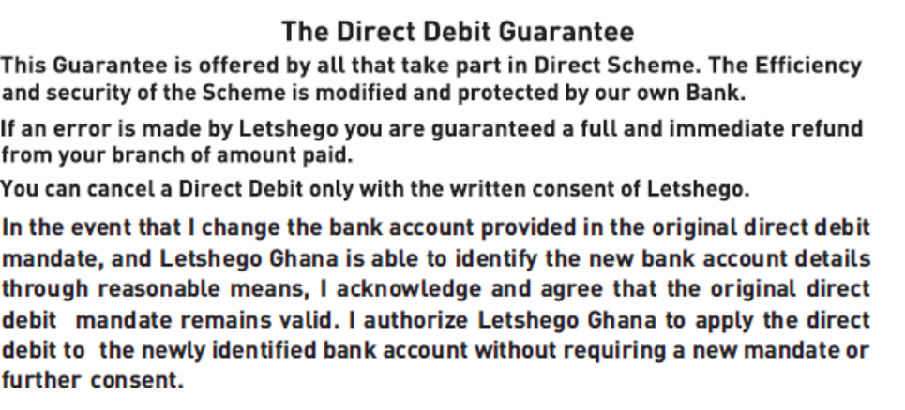

SIGNATURE AND DATE

